**Experiment: 1**

**Aim:** Create a structure named student that have member variable roll no, name, m1, m2, m3, sum, average, and grade. Program ask for roll no, name, m1, m2, m3 and calculate sum, average and grade.

**Software:** Dev C++

**Code:**

**#include<stdio.h>**

**struct student**

**{**

**int roll_no;**

**char name[30];**

**int m1;**

**int m2;**

**int m3;**

**}details;**

**int main()**

**{**

**int sum=0,avg=0;**

**printf("Enter The Name Of The Student:-");**

**scanf("%s",&details.name);**

**printf("Enter The Roll-no Of The Student:-");**

**scanf("%d",&details.roll_no);**

**printf("Enter The Marks-1:-");**

**scanf("%d",&details.m1);**

**printf("Enter The Marks-2:-");**

**scanf("%d",&details.m2);**

**printf("Enter The Marks-3:-");**

**scanf("%d",&details.m3);**

**sum=details.m1 + details.m2 + details.m3 ;**

**printf("\n\n");**

**printf("Name:- %s\n",details.name);**

**printf("Roll-no:-%d\n",details.roll_no);**

**printf("Marks-1:-%d\n",details.m1);**

**printf("Marks-2:-%d\n",details.m2);**

**printf("Marks-3:-%d\n",details.m3);**

**avg=sum/3;**

**if(avg>=90)**

**{**

**printf("Grade-A");**

**}**

**else if(avg>=80 && avg<90)**

**{**

**printf("Grade-B");**

**}**

**else if(avg>=70 && avg<80)**

**{**

**printf("Grade-C");**

**}**

**else if(avg>=50 && avg<60)**

**{**

**printf("Grade-D");**

**}**

**else if(avg>=40 && avg<50)**

**{**

**printf("Grade-E");**

**}**

**else if(avg>=33 && avg<40)**

**{**

**printf("Grade-F");**

**}**

**else**

**{**

**printf("FAIL");**

**}**

**}**

**Output:**

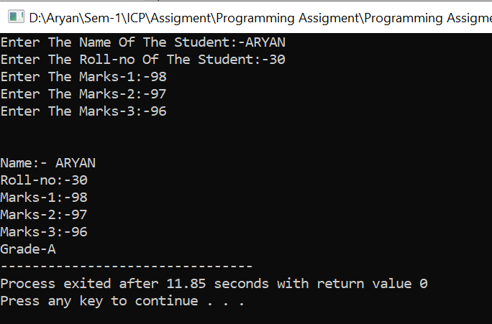

**Experiment: 2**

**Aim:** Write a program that access the structure variable using pointer

**Software:** Dev C++

**Code:**

**#include <stdio.h>**

**#include <string.h>**

**struct Student**

**{**

**int roll_no;**

**char name[30];**

**char branch[20];**

**int batch;**

**};**

**int main()**

**{**

**struct Student s1;**

**struct Student* ptr = &s1;**

**printf("Enter The Roll-no:-");**

**scanf("%d",&s1.roll_no);**

**printf("Enter The Name:-");**

**scanf("%s",&s1.name);**

**printf("Enter The Branch:-");**

**scanf("%s",&s1.branch);**

**printf("Enter The Batch:-");**

**scanf("%d",&s1.batch);**

**printf("Roll Number: %d\n", (*ptr).roll_no);**

**printf("Name: %s\n", (*ptr).name);**

**printf("Branch: %s\n", (*ptr).branch);**

**printf("Batch: %d", (*ptr).batch);**

**return 0;**

**}**

**Output:**

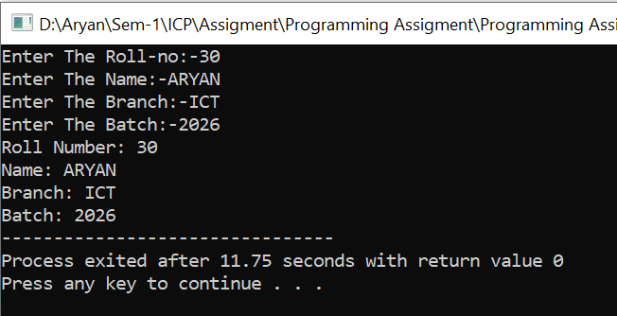

**Experiment: 3**

**Aim:** Create a user define function named prime which accept one argument (of integer type) and display that the no is prime or not. (no need to return value)

**Software:** Dev C++

**Code:-**

**#include<stdio.h>**

**int prime(int num)**

**{**

**int i;**

**for(i=2;i<num;i++)**

**{**

**if(num%i==0)**

**{**

**break;**

**}**

**}**

**if(num==i)**

**{**

**return 1;**

**}**

**else**

**{**

**return 0;**

**}**

**}**

**int main()**

**{**

**int num,primen;**

**printf("Enter The Number:-");**

**scanf("%d",&num);**

**primen=prime(num);**

**if(primen==1)**

**{**

**printf("%d Is A Prime Number",num);**

**}**

**else**

**{**

**printf("%d Is Not A Prime Number",num);**

**}**

**return 0;**

**}**

**Output:**

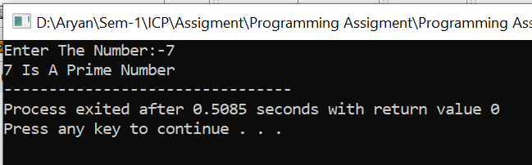

**Experiment: 4**

**Aim:**  Write a program to compare two dates entered by the user. Make a structure named  
Date to store the day, month, and year. If the dates are equal, display “Dates are equal”;  
otherwise display “Dates are not equal”.

**Software:** Dev C++

**Code:-**

**#include<stdio.h>**

**struct date**

**{**

**int date;**

**int month;**

**int year;**

**}dates[2];**

**int main()**

**{**

**for(int i=0;i<2;i++)**

**{**

**printf("Enter The Date-%d:-",i+1);**

**scanf("%d",&dates[i].date);**

**printf("Enter The Month-%d:-",i+1);**

**scanf("%d",&dates[i].month);**

**printf("Enter The Year-%d:-",i+1);**

**scanf("%d",&dates[i].year);**

**}**

**if(dates[0].date==dates[1].date && dates[0].month==dates[1].month && dates[0].year==dates[1].year)**

**{**

**printf("Dates are Equal");**

**}**

**else**

**{**

**printf("Dates are Not Equal");**

**}**

**return 0;**

**}**

**Output:-**

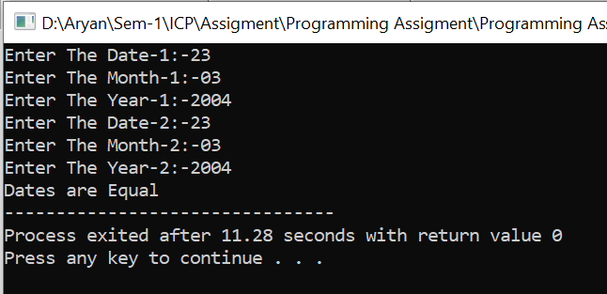

**Experiment: 5**

**Aim:-**  Write a program to sort an array in descending order by passing the array to a Function.  
(Use Pointers)

**Software:-** Dev C++

**Code:-**

**#include <stdio.h>**

**void sort(int n, int* ptr)**

**{**

**int i, j, t;**

**for (i = 0; i < n; i++) {**

**for (j = i + 1; j < n; j++) {**

**if (*(ptr + j) < *(ptr + i)) {**

**t = *(ptr + i);**

**\*(ptr + i) = *(ptr + j);**

**\*(ptr + j) = t;**

**}**

**}**

**}**

**for (i = 0; i < n; i++)**

**printf("%d ", *(ptr + i));**

**}**

**int main()**

**{**

**int n = 5;**

**int arr[n];**

**for(int i=0;i<n;i++)**

**{**

**printf("Enter The Number At Index-%d:-",i+1);**

**scanf("%d",&arr[i]);**

**}**

**sort(n, arr);**

**return 0;**

**}**

**Output:-**

